**MongoDB Lab Assignment 2 - Aggregation**

**Import Database from zip.json file**

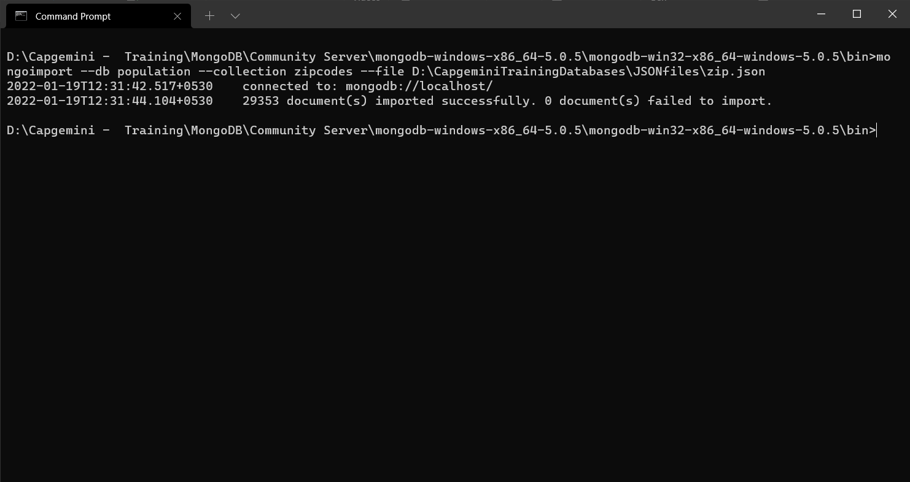

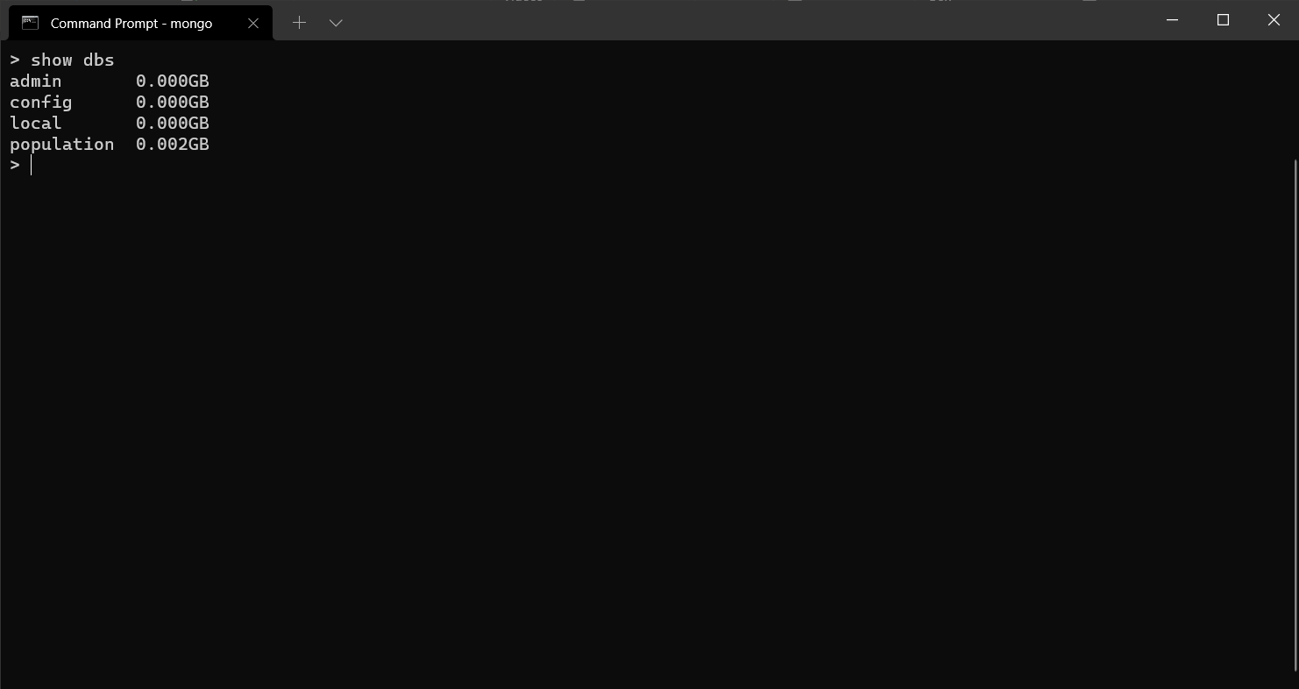

**Atlanta Population**

1. use db.zipcodes.find() to filter results to only the results where city is ATLANTA

and state is GA.

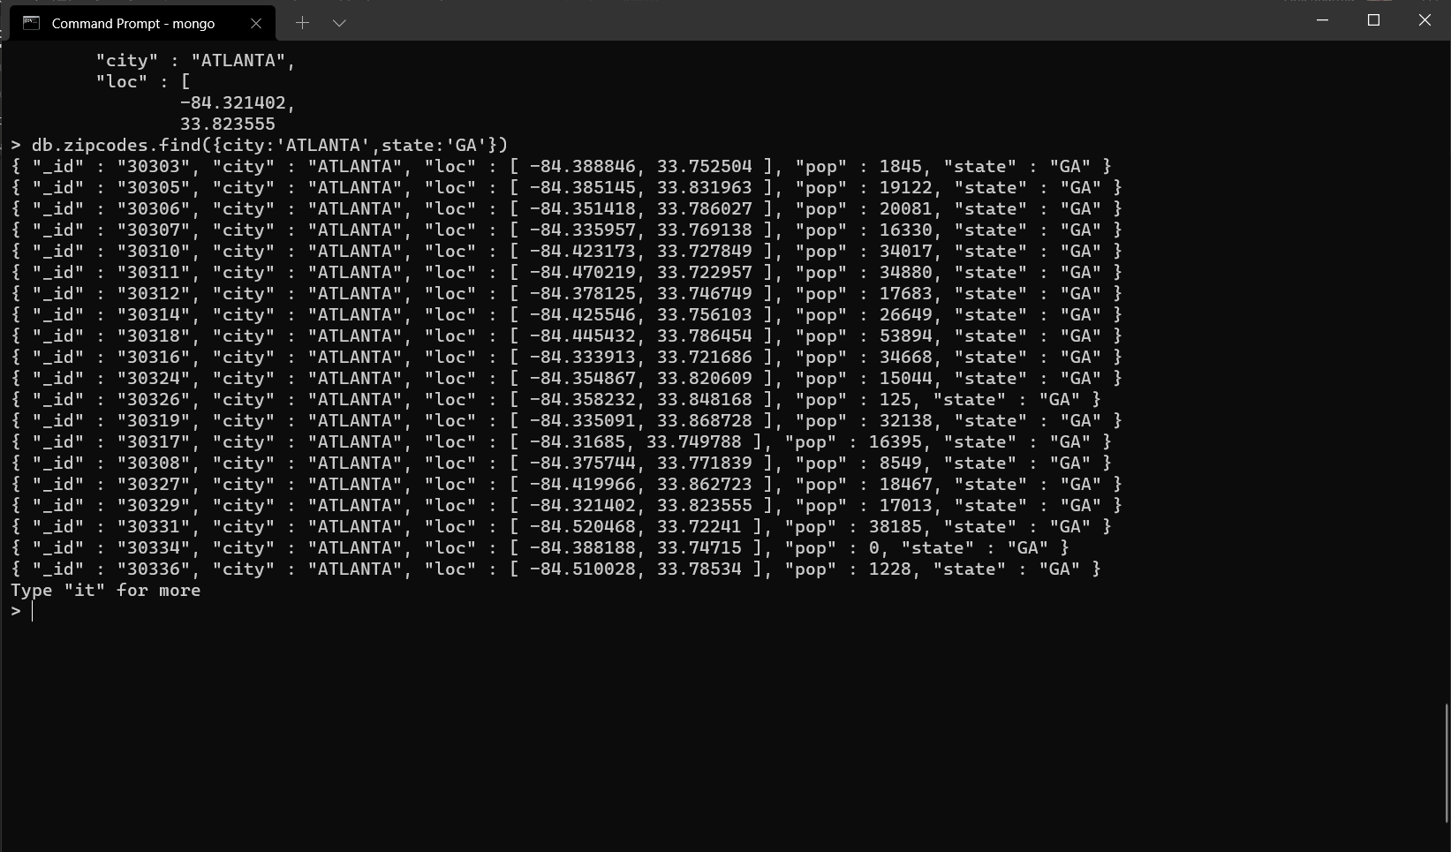

2. use db.zipcodes.aggregate with $match to do the same as above.

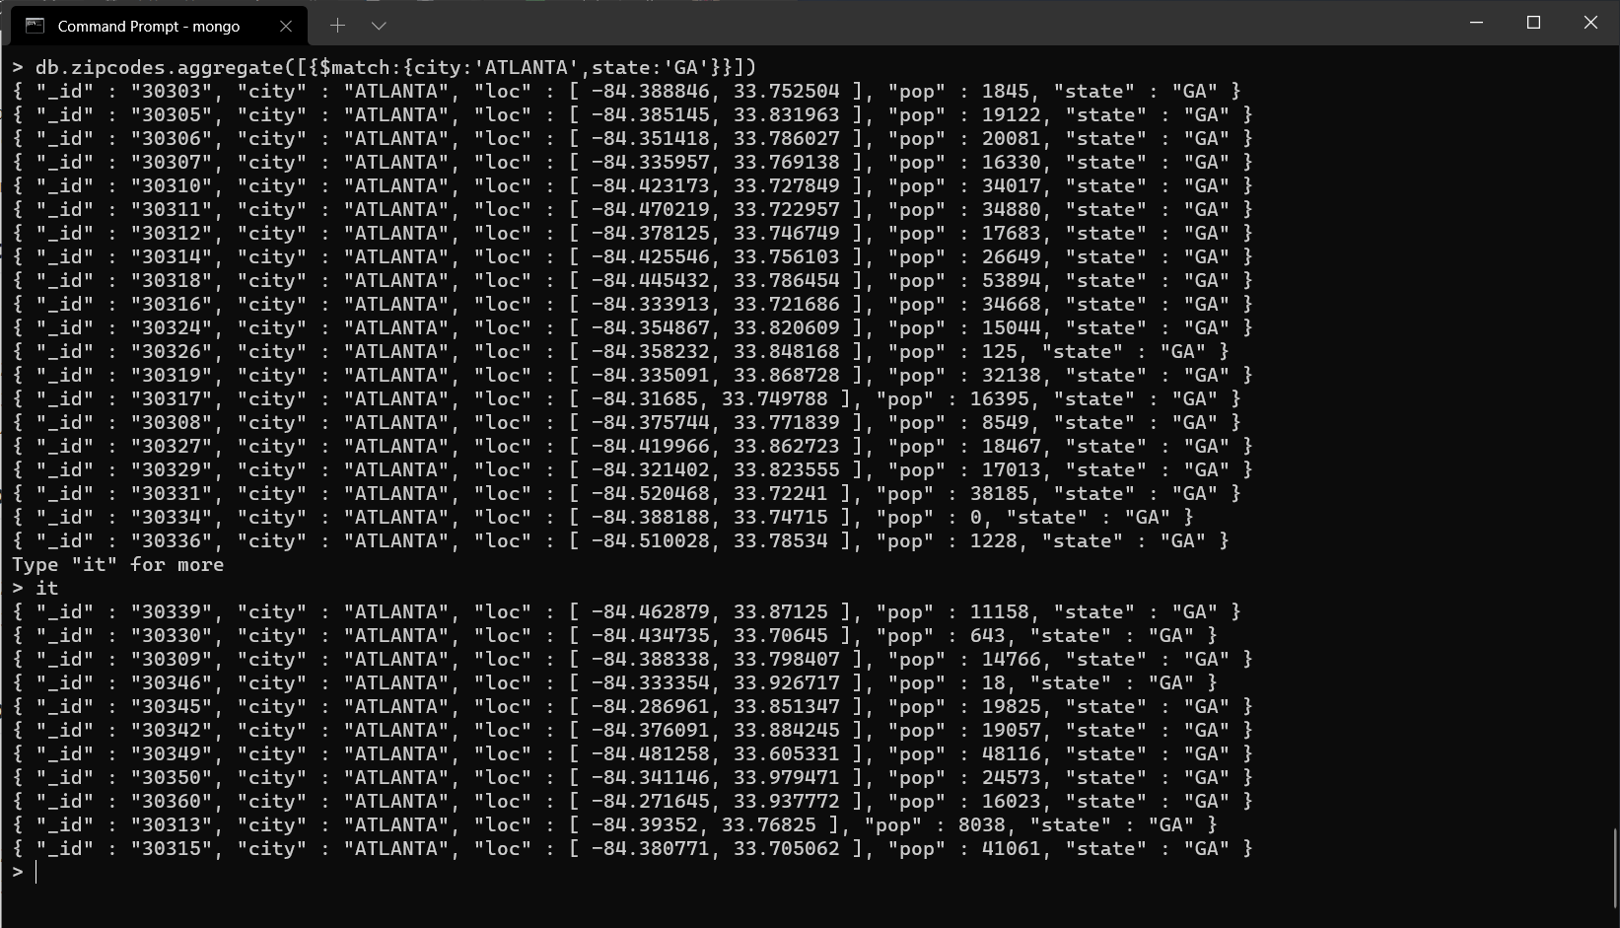

3. use $group to count the number of zip codes in Atlanta.

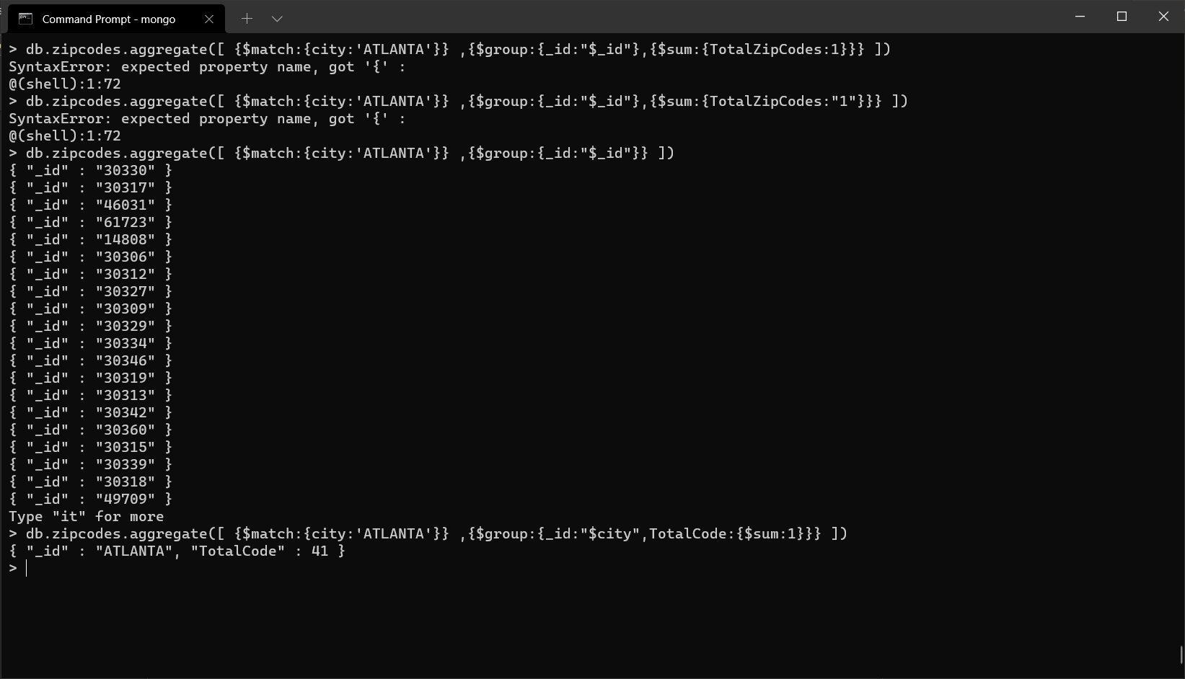

4. use $group to find the total population in Atlanta.

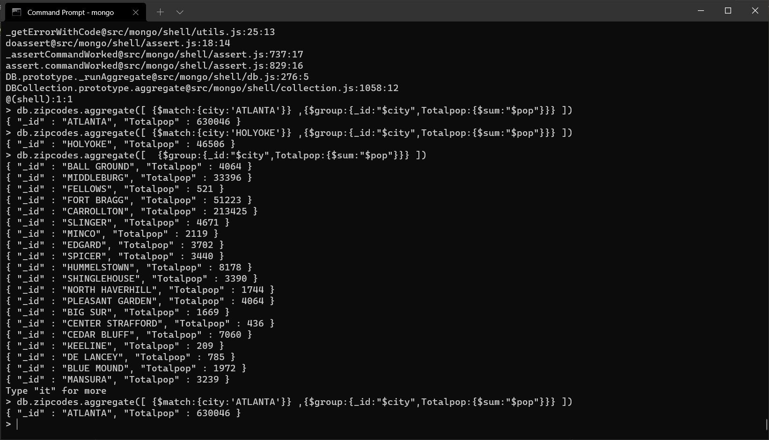

**Populations By State**

1. use aggregate to calculate the total population for each state

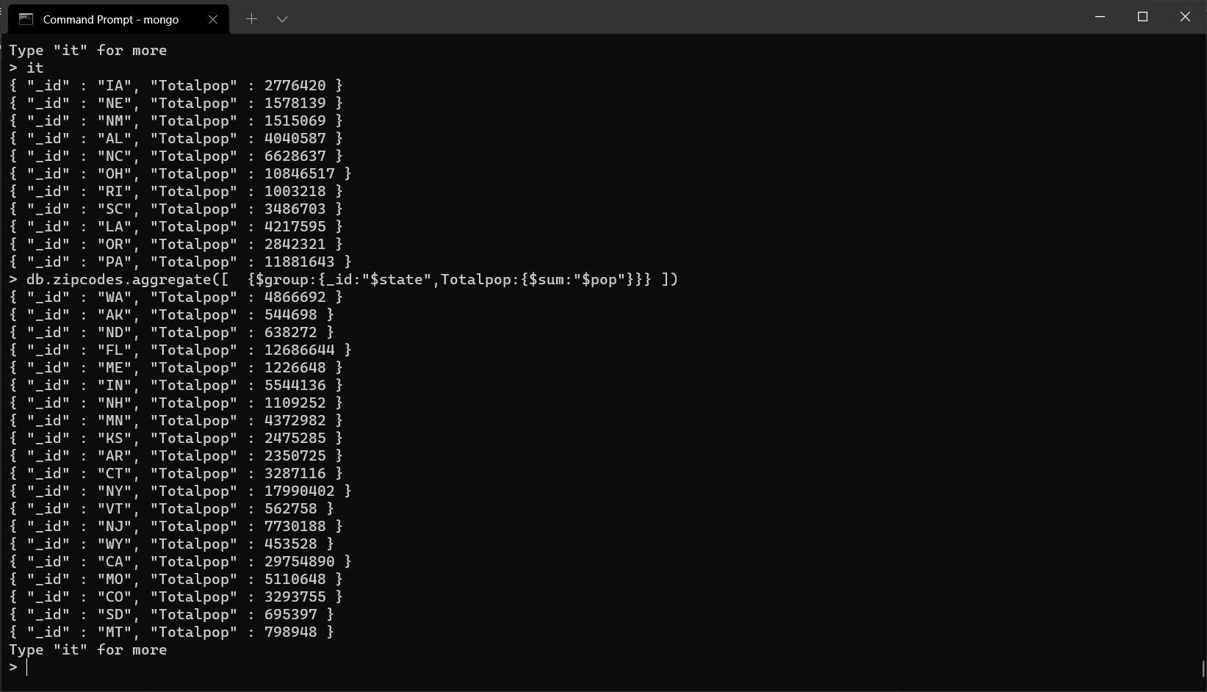

2. sort the results by population, highest first

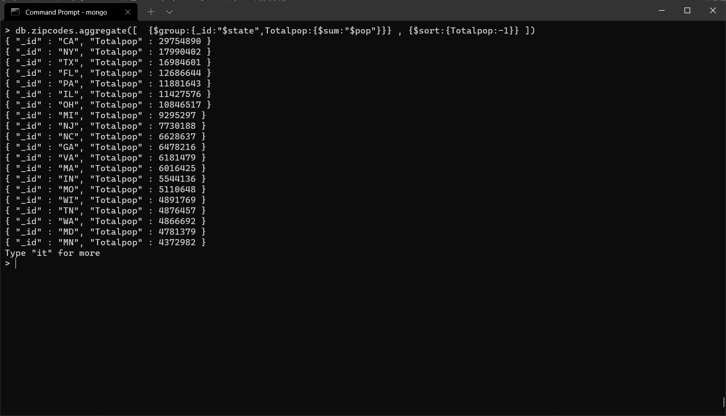

3. limit the results to just the first 3 results. What are the top 3 states in

population?

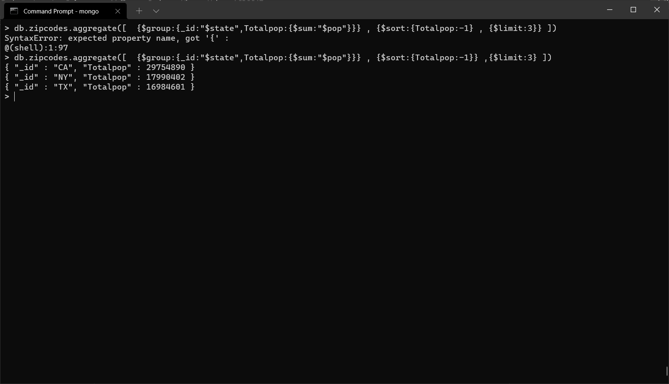

**Populations By City**

1. use aggregate to calculate the total population for each city (you have to use city/state combination). You can use a combination for the _id of the $group: { city: '$city, state: '$state'}

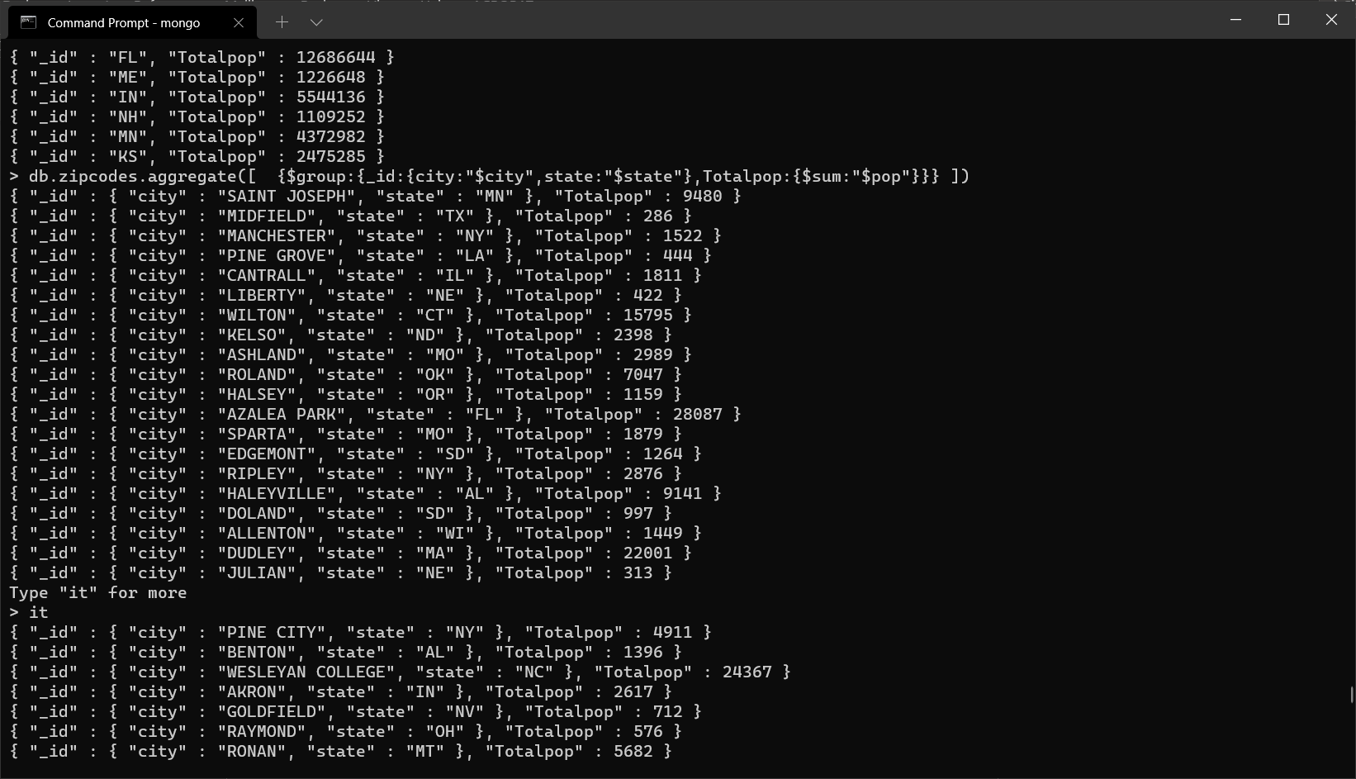

2. sort the results by population, highest first

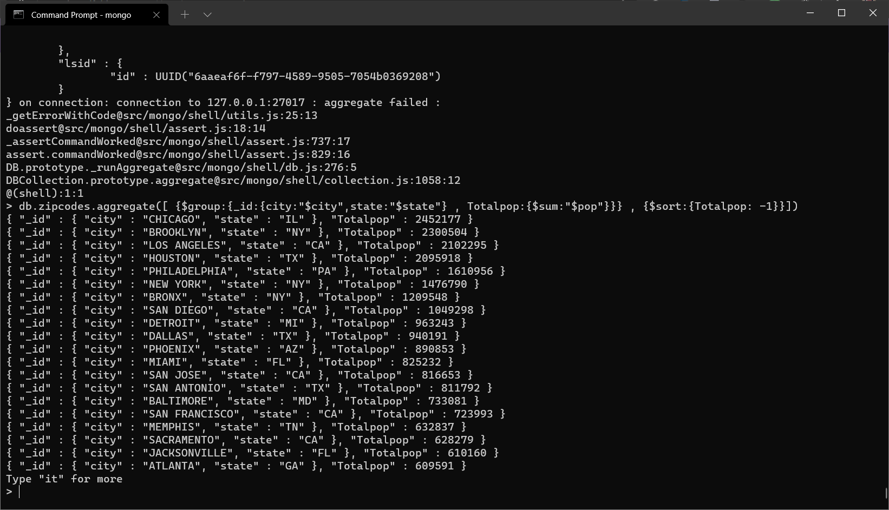

3. limit the results to just the first 3 results. What are the top 3 cities in population?

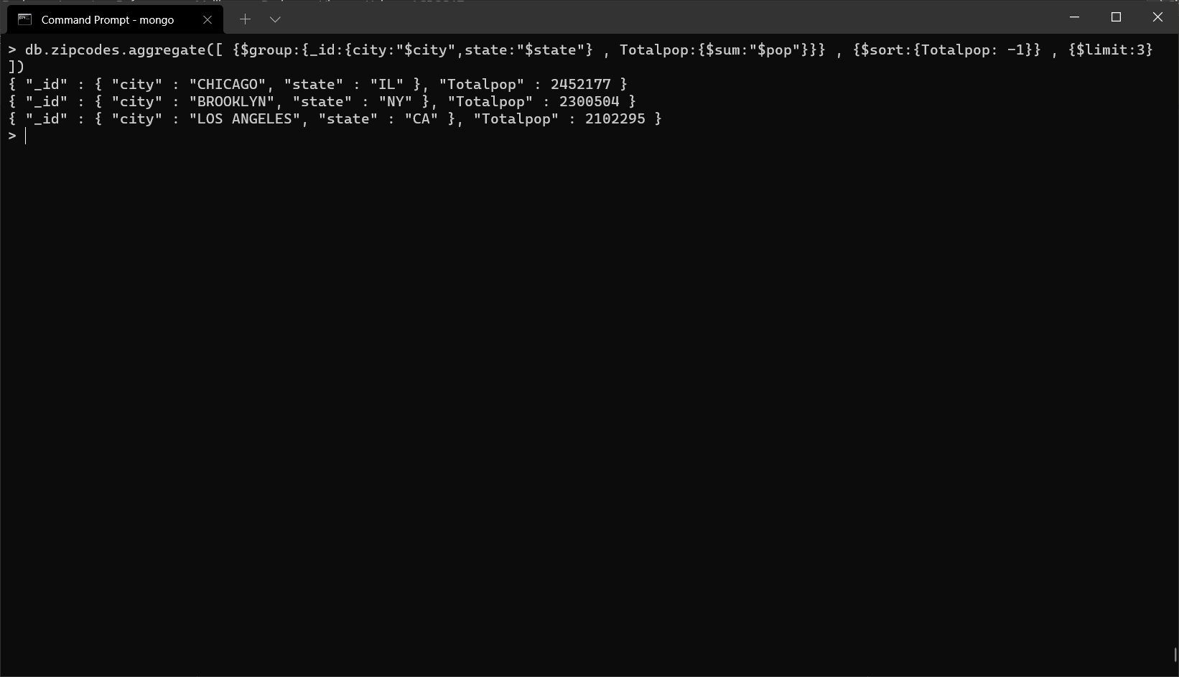

4. What are the top 3 cities in population in Texas?

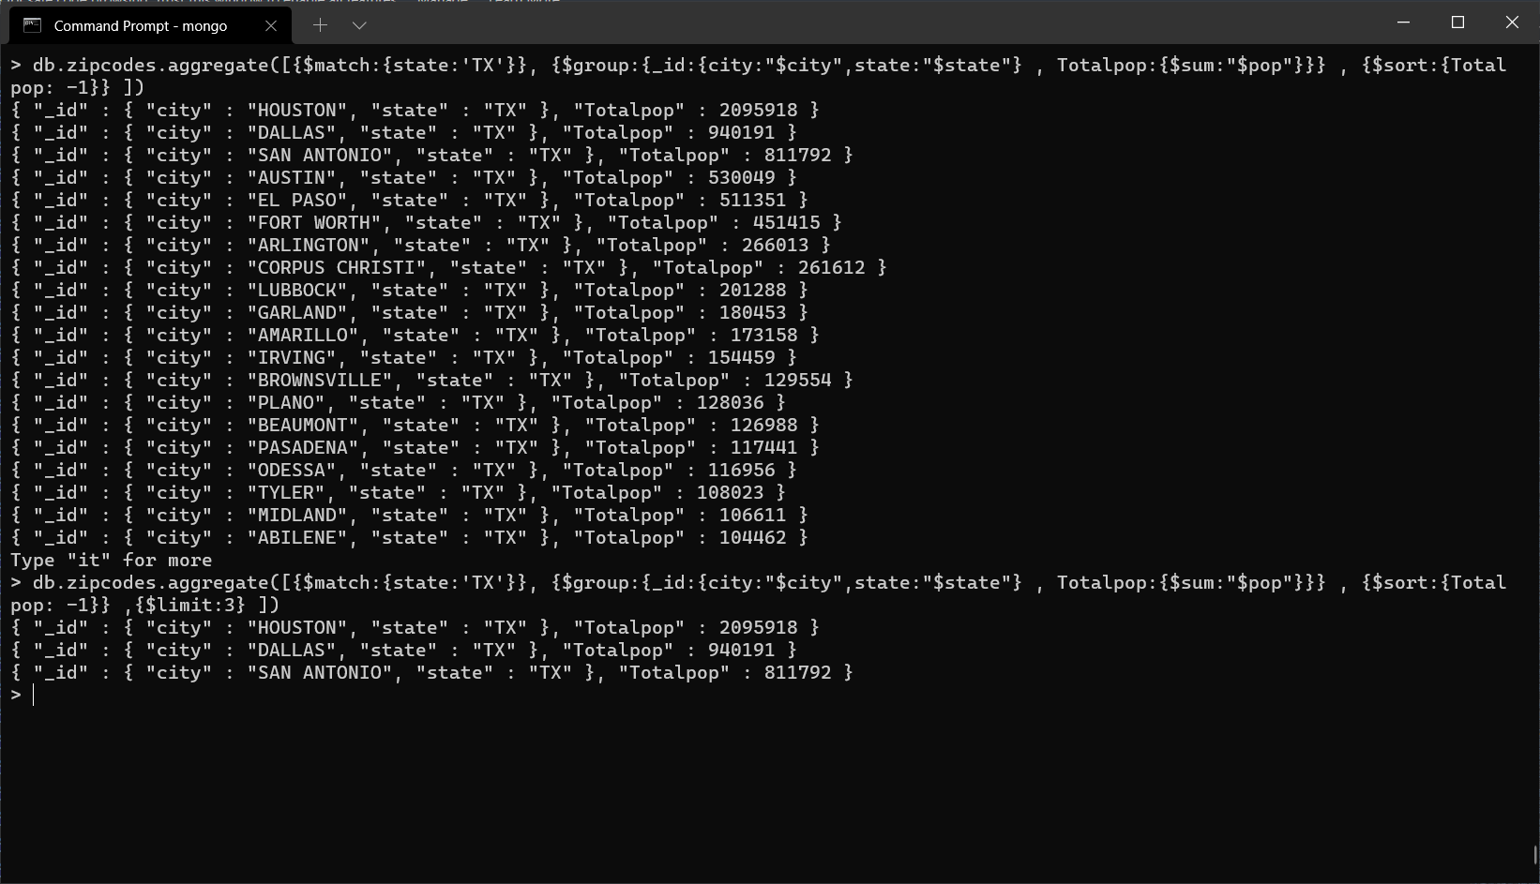

**Bonus**

1. Write a query to get the average city population for each state.

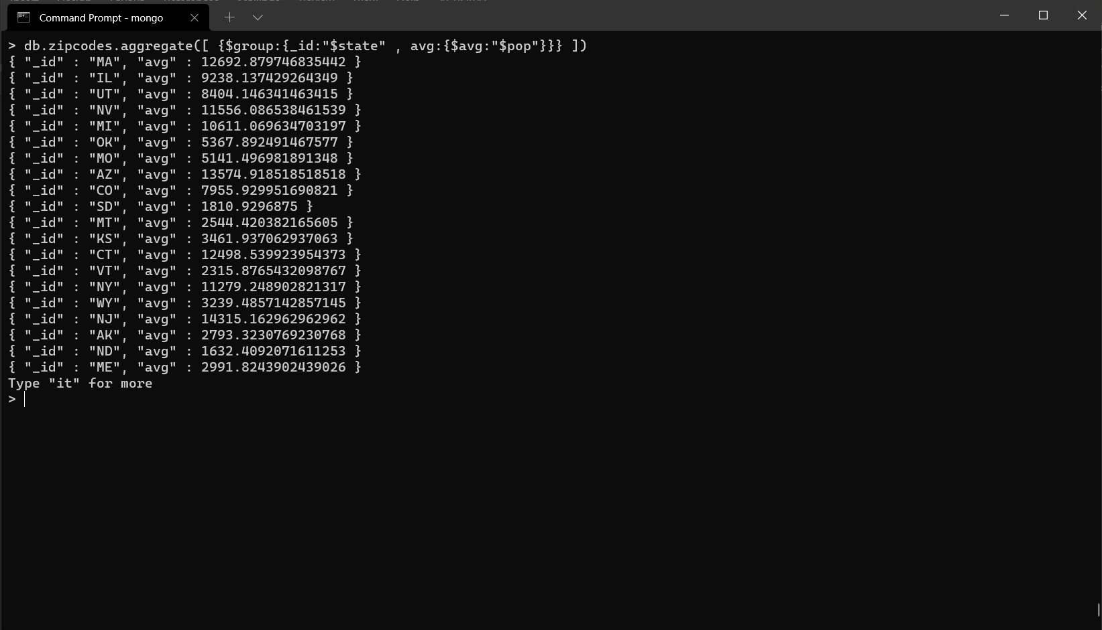

2. What are the top 3 states in terms of average city population?

